Topola as a small town of great cultural and historical importance

In the area of Topola, there were settlements in the Middle Age. First time this town was mentioned in the 18th century, during the Austrian rule (1718-1739) as Kamenica. Nowadays Topola as a settlement was formed during the First Serbian Uprising (1804-1813). At that time, Topola was the residence of Vozd Karadjordje, leader of the First Serbian Uprising. He built Karadjordje's forted town. From that town, Church and residence remain till today. Topola experienced the rise in the beginning of early 20th century, during the rule of Karadjordje's grandson King Peter I (1903-1921). His foundation is a magnificent mausoleum at Oplenac, the hill above Topola.
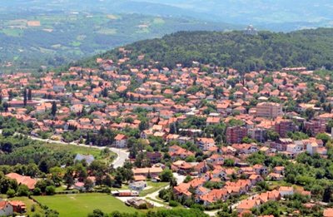

Church of St. George in Oplenac, the Foundation of King Petar I Karadjordjevic
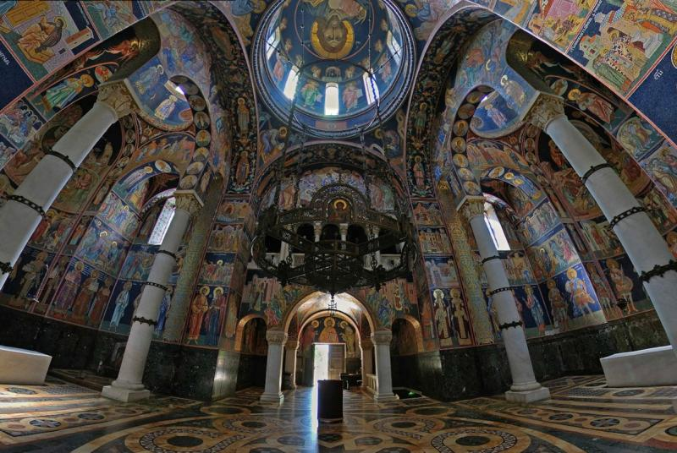
The interior - frescoes in the mosaic

Significant cultural and historical heritage of Topola and its area are medieval monasteries, Nikolje, Blagovestenje (Annunciation), Brezovac, Voljavča, St. Petka (Paraskeva) and church in Gorovic. The remains of the so-called Bakić palace were found in the village Banja, as well as remains of Djura's cells (kellias) in Manojlovci. Small town Natalinci, on the road from Topola to Smederevska Palanka, is interesting by the old crafts. Birthplace of the greatest Serbian satirist Radoje Domanović was restored in the village Ovsište, near Topola. Topola is known as a wine-growing region. As part of the Foundation of King Petaris a winery, that is a cultural and historical landmark. The Oplenac's vintage, an event dedicated to grape picking and wine is organized every October in Topola since 1962. The Oplenac’s vintage is one of the five most important and most visited events in Serbia.

1. Oplenac

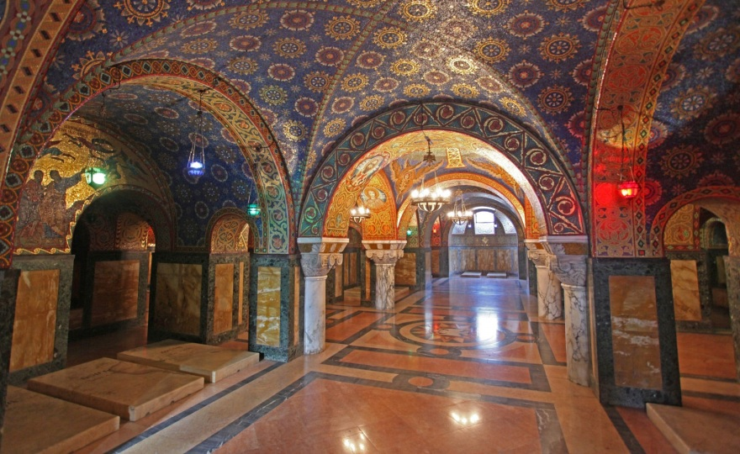
Memorial crypt
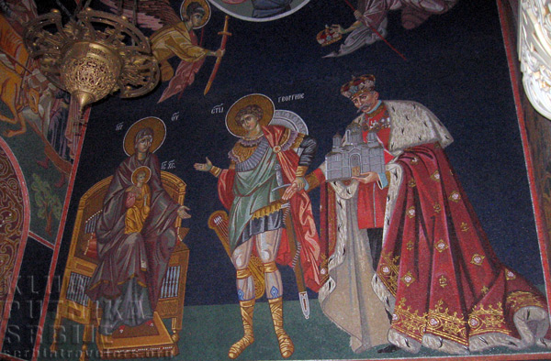

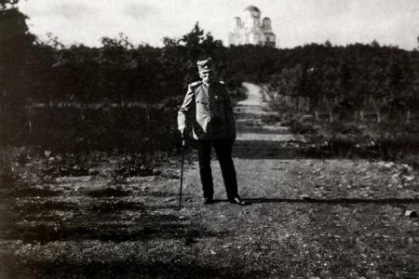
King Petar I Karadjordjevic at Oplenac
1.1. Mausoleum

The most representative building of the Foundation of King Peter Iis the Church of St. George, the family mausoleum of the Karadjordjevic dynasty.
Construction of the church began on 1st May 1910. During the Balkan wars, King Peter idea was that the church became the temple of soldiers died from 1912 to 1913. He wanted the interior of the church covered with plates of white marble from Venčac, and to write the names of the fallen warriors in gold letters. But then, there followed the First world war and every fourth resident in Serbia was killed. King Peter gave up from his first idea, since all names would not be placed in church. After First World War, King Peter came to Serbia in 1919., old and sick stayed in Belgrade, where he died on 16th August 1921. Interior decoration continued his son, King Alexander I.
Two years after the death of his father, King Alexander chose the mosaic for the interior and he also chose a group of Russian artists, led by Smirnov and Krasnov. Their task was visiting Orthodox shrines - monasteries and churches in Serbia and Macedonia. Russian artists marked down the most beautiful frescoes, and then they finished sketches were sent to Berlin, to the Paul und Wagner firm, where compositions of the mosaic were made.

The surface of the mosaic is 3,500 square meters, and 40 million colorful mosaic tiles with 15,000 shades of colors are put in 725 compositions (513 in the church and 212 in the crypt). A special place in the mosaic colors occupies Ktitor's compositionon the right side of the church entrance. Modeled after the ktitor's compositions from Gracanica and Nagorican. King Petar with a model of his foundation, guided by St. George (the patron of the church), contribute his church to the Virgin with Christ in her lap for a blessing. The figure of King Peter, was made according to portrait painted by Paja Jovanovic, after the coronation of the king on 21st September 1904.

Today, twenty-nine members of the Karadjordjevic family rest at Oplenac church. Among them, the five rulers of Serbia and Yugoslavia, and two rulershave honorary graves in the church. In the upper area of the church, in two sarcophagis, rests Karadjordje as a founder of the dynasty and King Peter as the founder of the church.

1.2 House of King Peter

Opposite the church, there is a building known as kingPeter's house. Construction of the house was started in 1910. and it was completed in 1912 after the project of Kosta Jovanovic. After the First World War, there was a Management of Foundation in the house, and after the assassination of King Alexander the house was the Museum of wreaths that were laid on the grave of King Alexander.
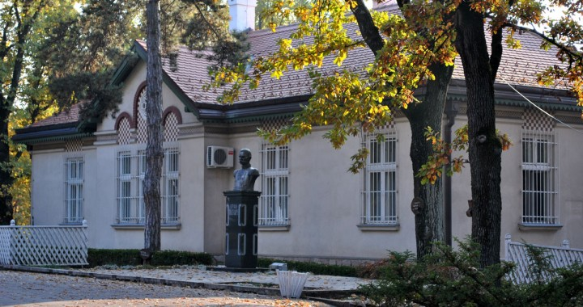
House of King Peter in Oplenac
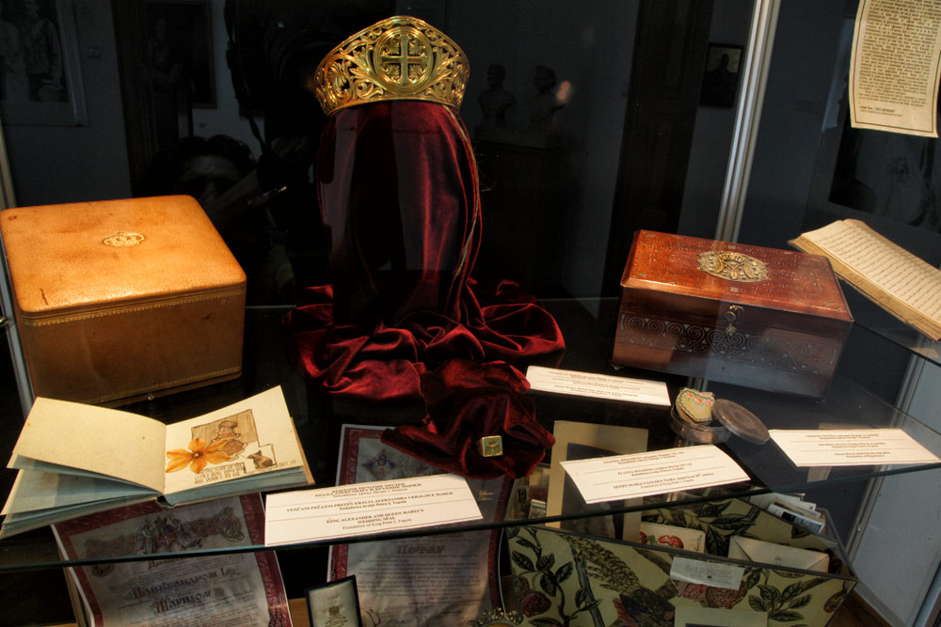House of King Peter in Oplenac -museum exhibits - personal belongings of the family Karađorđević

Currently, the icons from the Treasury of church are exposed in the gallery of the house of King Peter. These icons were gifted to King Peter and King Alexander. The central place in the exhibition occupies Last Supper icon, made from nacre, a gift from the Jerusalem Patriarch Damian to King Alexander in 1924. Icon was made in Jerusalem in the 19th century. The second part of the exhibition are personal belongings of King Alexander and Queen Mary.

1.3 Castle of Karadjordje (Karadjordje town)

During the First Serbian Uprising, Karadjordje Petrovic started a large construction venture in his headquarters in Topola. He was building a fortified town from 1811. to 1813. The town had the shape of a regular tetragon , surrounded by stone walls, high from 2.5 to 3 meters, with towers at each corner. Museum exhibition is a testimony of the First Serbian Uprising and Karadjordje himself. The exibition is rich in documents, uprising’s weapons, personal items of vozd Karadjordje, a small ethno collection of the time, as well as the works of contemporary artists on the theme of the uprising.
One of the museum’s items, that occupies a special place, is the bronze Karadjordje's cannon from 1812., that was casted in Belgrade iron Foundry. At the time of the uprising, the cannon was set on Oplenac above Karadjordje's fortification, and it served to announce major events. It is known as Aberdare (cannon Herald or messenger). By order of Peter I Karadjordjevic, the right handle of cannon was ripped off to be melted and it became a part of his crown. In this way, Peter I symbolically tied his rule with Karadjordje’s warfare.
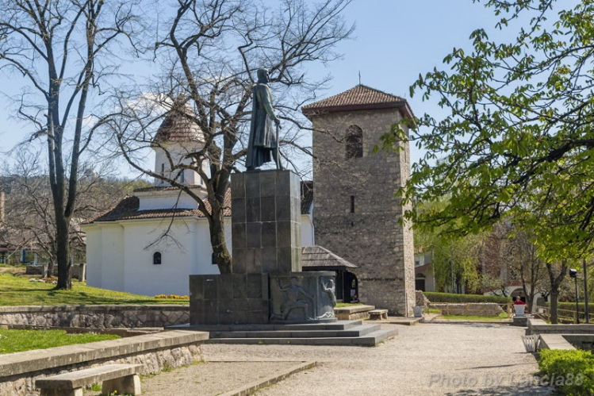
The monument of Karadjordje
The monument of Karadjordje, the work of Peter Palavičini from 1939. is located in the courtyard of Karadjordje town. The monument was never officially unveiled. It has been sculpted by orders of Prince Paul.
The Church of Nativity of the Virgin Mary was built in 1811. It is a single nave church. The church is famouse for its iconostasis from 1928.
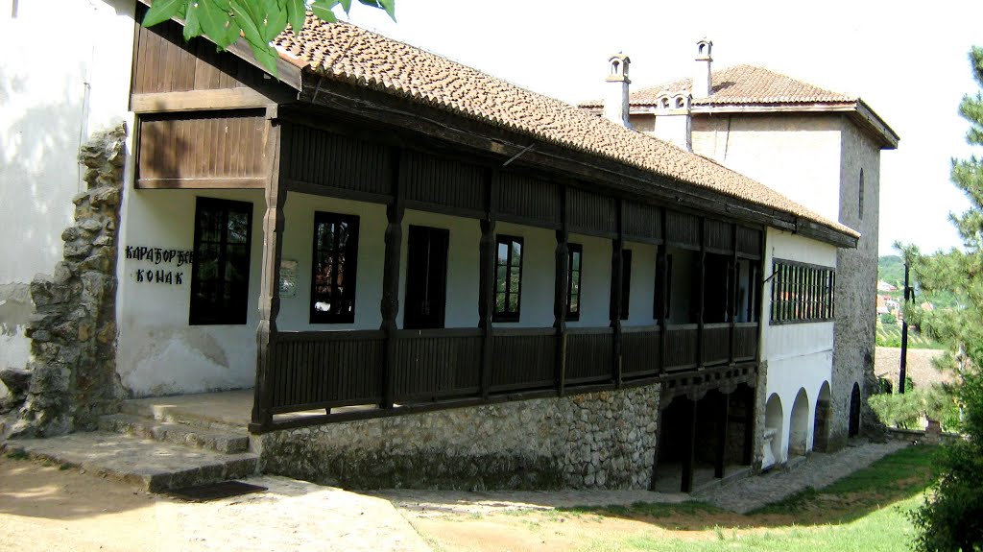
Castle of Karađorđe – The residence of Karađorđe
Castle of Karađorđe at the time of the First Serbian Uprising

Castle of Karađorđe at begining of XX century
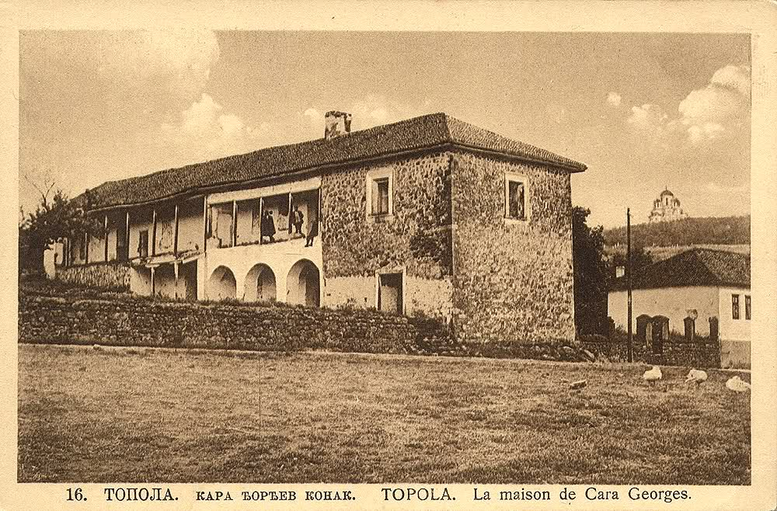

2. Monasteries and churches near Topola

The temples date from the late Middle Age. Among them, the special reputation have the followingones:
- Annunciation on Rudnik
Annunciation (Blagovestenje rudnicko) dates from the 14th century and it was restored in the late 18th century. The monastery has interesting murals and objects (large cross with the crucifixion of Christ). The monastery is located in the small town Stragari.
- St. Petka
Not far from the Annunciation is the monastery of St. Petka, which dates from the first half of the 14th century.
- Voljavča
5 km from Stragari, The Church of St. Archangel Michael was built in the first half of the 15th century. In the second half of the 18th century, the monastery was the target of the Turks for 2 times, but it was restored by the end of the 18th century. The monastery konak is famous for the fact that it was the headquarterof the Serbian Government for some time at the time of the First Serbian Uprising.
- Nikolje
The monastery was built in 1425. as a foundation of Nicola Dorjanovic. It was demolished in the Turkish era but renovated in the 19th century.
- Brezovac
The monastery was built in 1444. as a foundation of Despot Djuradj Brankovic, located at the foothill of the mountain Venčac. The monastery was active until the end of the 16th century, then abandoned and rebuilt in 1795. It was declared as the monastery at the end of the 20th century.
- The Church in Gorovic
It was built by the national tradition by Despot Stefan Lazarevic in 1396. It was renovated in the 17th and 18th century. However, the temple is not operational and it is required for restoration.

- Djura's cell

The latest archaeological researches have confirmed the remains of the monastery cells (kellias) in Manolovci called Djura's cells as well as the remains of the so-called Bakic palace in Banja.

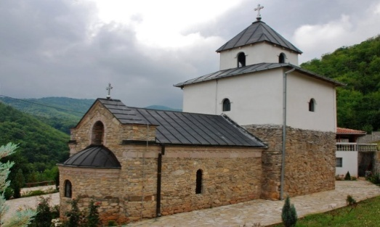

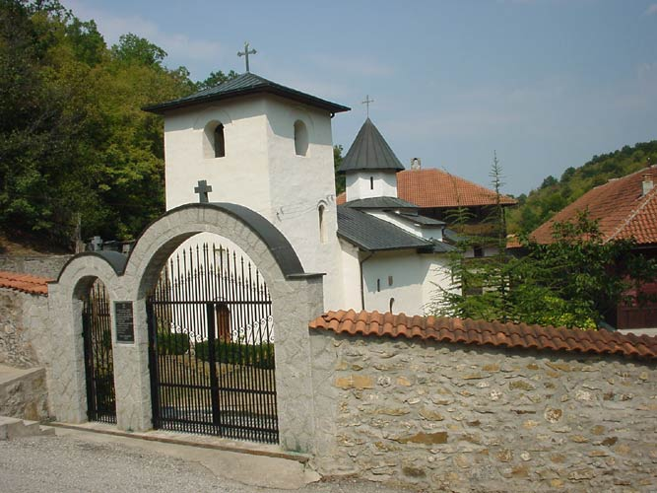
Monastery Voljavča (Manastir Voljavča)
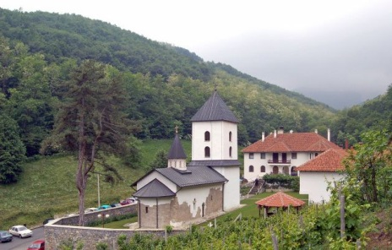
Monastery Nikolje (from 1425.

Monastery of St. Petka in Stragari

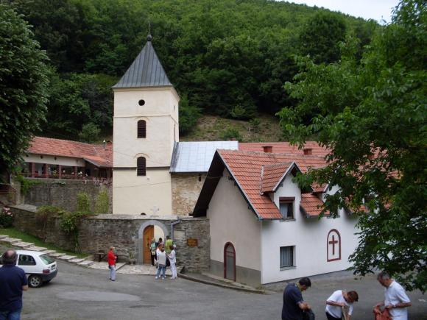
Monastery Blagovestenje

Monastery Voljavča

Monastery Nikolje

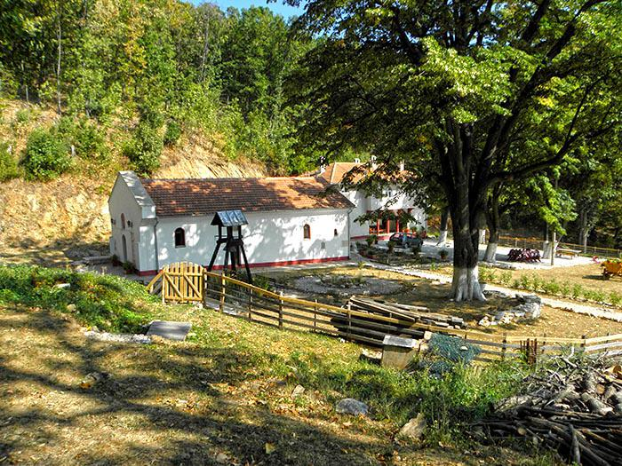
1. Monastery Venčac at Brezovac (also known as the Monastery Brezovac, built in 1444.)
2. Church in the village Gorovič (14th century)
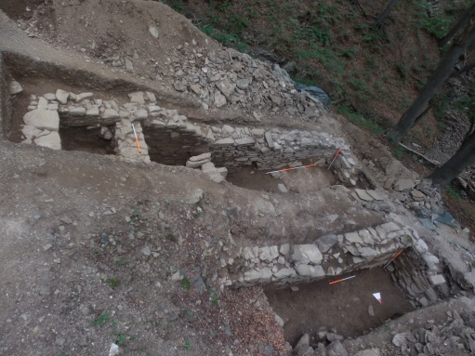
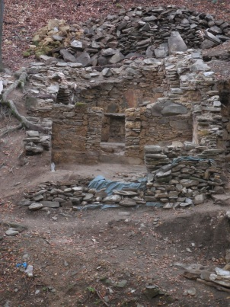
The discovery of the remains of the monastery kelija caused a lot of public attention - site "Djura’s cell
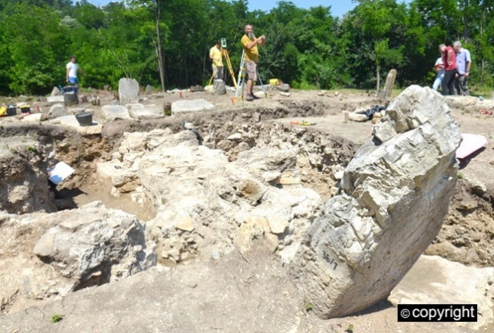
Archaeologists found the remains of churches and palaces from the 14th and 16th centuries under Venčac, mountain near Topola 1.

3. Othersights

3.1 Ovsište
Radoje Domanović, the largest Serbian and Yugoslav satirist, was born in Ovsište in 1873. His family home was renovated in December 2015 and it represents a cultural and historical memorial.

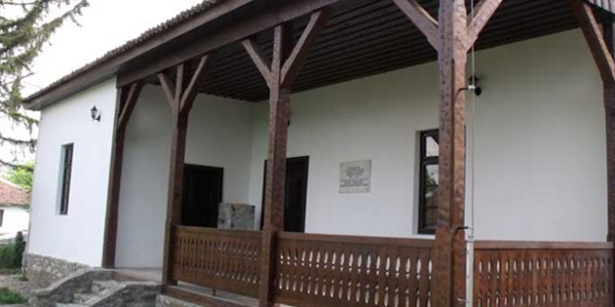
Restored house of RadojeDomanović in Ovsište near Topola

4. Winery

The first building of the winery complex King Petar was finished in 1915. Not having enough space in the so-called old wine cellar, king Aleksandar built a much larger winery. The building was completed in 1931. There are three barrels decorated with carvings in the winery, which King Aleksandar got in 1922. as a wedding gift from his three nations - Serbs, Croatians and Slovenias. On the barrel donated by the Serbs, around the perimeter, there are carved words of their anthem "God of Justice", the Croatians printed the beginning of the song "Our Beautiful", and the Slovenias text of their festive song "Forward, flag of glory." At the bottom of each barrel there is the first letter of the nation, so that together they form the state abbreviation SHS. There is a wine collection in the winery, with precious samples of the first wine produced in 1931, which was even then "left to history."
In Banja, village near Topola, there was the biggest wine cooperative in the Balkan, and king Aleksandar was its sharehold.
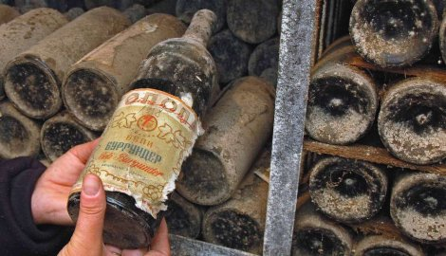
Wine collection in Oplenac winery
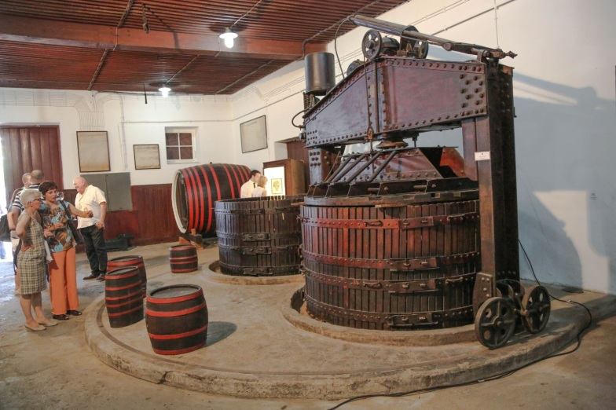
Winery in Oplenac - museum exhibition

5. Events
- Oplenac’s vintage
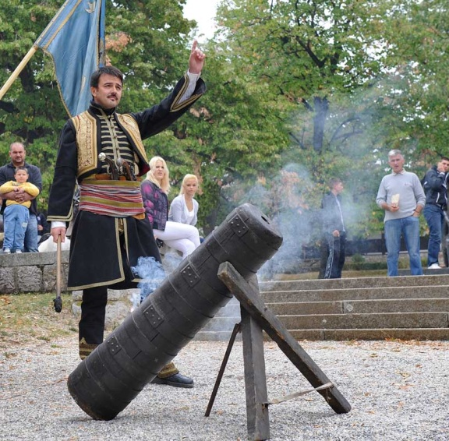
A commercial tourist event Oplenac’s vintage has been organized in Topola since 1962. This festival shows original folk creativity, all in honor of wine and grapes. This event has been declared as one of national importance.

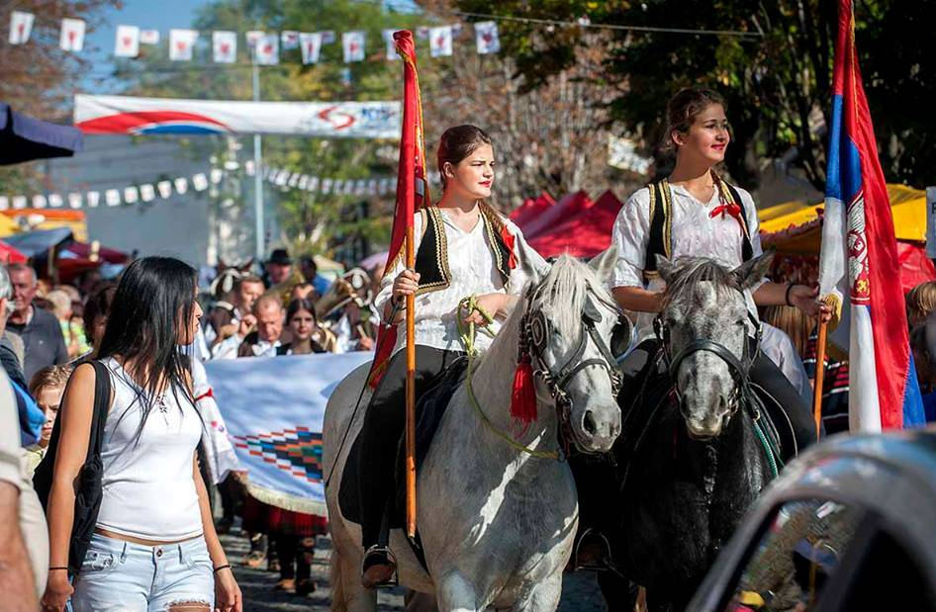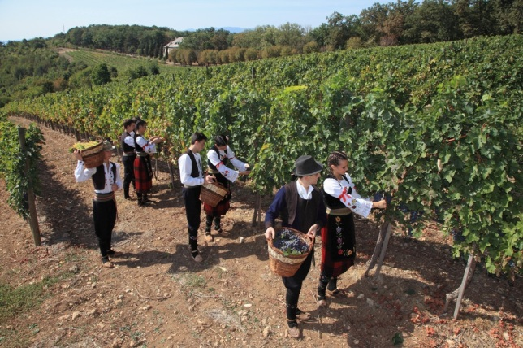
The Vintage of Oplenac is one of the most visited tourist events in Serbia
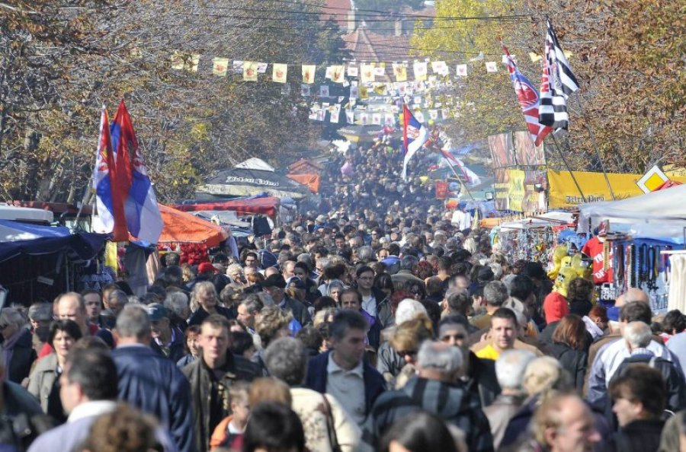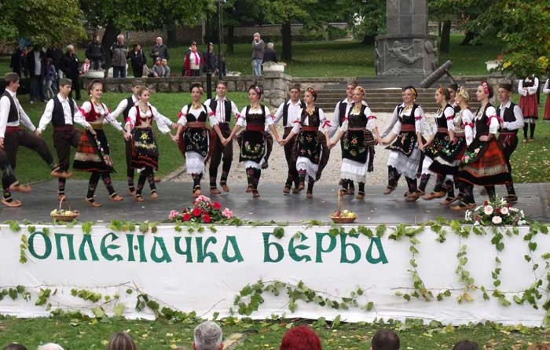
- Lipovac colony
Lipovac art colony was founded in the village Lipovac, nearTopola in 1973. This is a cultural event of national importance. A lot of artists from Serbia and from abroad take part in the event.

Topola is a hometown of several important representatives of culture, science, social and political life, such as Jovan Skerlić, Radoje Domanović, Desimir Blagojevic, Micha Zecevic and others.

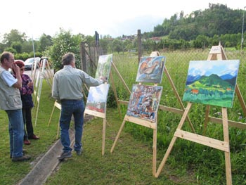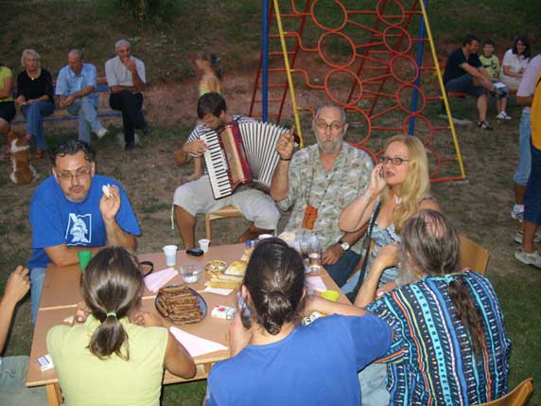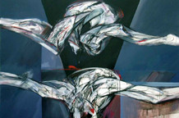 Art Colony in Lipovac
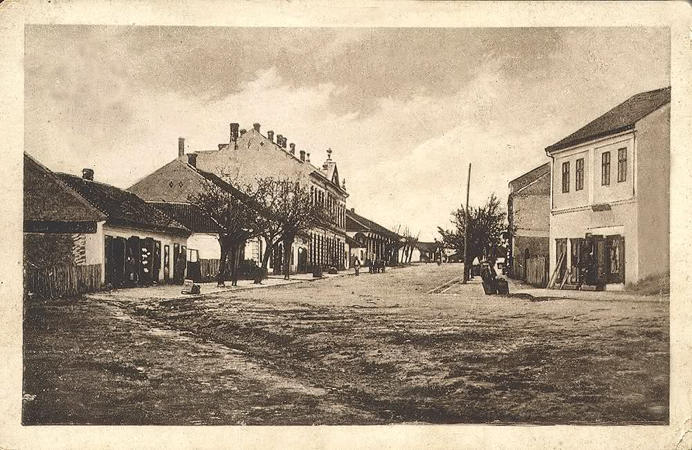Topola at the beginning of XX century

